User Manual

HDMI HDBaseT Extender

HDBT-HDMI-70/100TR-AE
HDMI Twisted Pair Extender

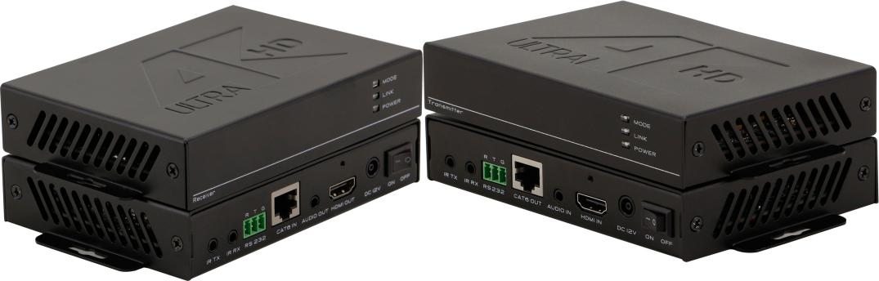

Version: V2016.001

Contents
1. Production 3
2. Features 3
3. Specification 3
4. Packing 4
5. Front Panel 5
6. Operation 5
6.1 Connection Diagram 5
6.2 POC 6
6.3 Bi-directional IR 6
6.4 RS232 control 7
6.5 Indicators 7
6.6 EDID Management DIP switch 8
6.7 RJ-45 Cable connector 8
6.8 RJ-45 cable using requests 8
7. Common Problem Shooting 9
7.1 Common problem 9
7.2 Notice 9
8. After Sales 10
8.1 Warranty Information 10
8.2 Warranty limitation and excptation 10
9. Version Information 10

1. Introduction
HDBT-HDMI-70/100TR-AE is an HDBaseT technology extender, it supports no compression, no losses, no latency HDMI signal transmission. It can can work with other HDBaseT equipment, such as Sony HDBaseT projector. All the signals are transmitted by one single CAT5E/ CAT6/ CAT7 cable, for 1080P it can transmit to a distance of 70/100m(230/328ft), for 4K30Hz, it can up to 35/70m(115/165ft). Compatible with all the HDTV resolutions, HDMI1.4a protocol. It also support bi-directional RS232 and IR transmission and realize the long distance control. Supports power over cable, users only need to power one side; Supports Audio embedded and de-embedded function, it can help users to have more choice whether the internal or external audio input and output; Supports EDID management, it provides users a wider way to work with different displays. So it can be popularly used in media conferencing room, school, government, cinema and so on applications.

- Features
- Transmit highest quality audio and video, for 1080p can up to 220/330 feet and 4K can up to 110/ 165 feet with Cat6/6a/7 cable
- Highest resolutions supported up to 4K2K@30Hz
- Equipped with EDID management capability
- Bidirectional IR/Serial control signal transmission
- Power over Cable (POC) locally powered over Cat5e/6 cable at either end
- Supports 7.1 DTS Master HD, Dolby True HD,
- Audio embedded and de-embedded

- Specification
Model | HDBT-HDMI-70T | HDBT-HDMI-70R
Input | 1*HDMI，1*3.5MM Audio, 1*RS232, 1*IR-TX, 1*IR-RX | 1XHDBaseT
Output | 1XHDBaseT | 1*HDMI，1*3.5MM Audio, 1*RS232, 1*IR-TX, 1*IR-RX
Protocol | Support HDMI1.4a and compatible with HDCP, EDID Management
Resolution | 480i, 576i, 480p, 576p, 720p, 1080i, 1920 x 1080p up to 60Hz 3840/4096 x 2160 up to 30Hz
Color Space | 1080p: 36Bit Deep Color 4K: 24Bit True Color, 4:2:2
Bandwidth | 10Gbps
Transmission Distance | CAT5e/6 cable: 70m(1080p60Hz)  35m(4K30Hz)
Dimension | 152×100×27（mm）
Weight | 200g
Power | AC: 100-240V 50/60Hz 1.5A Max DC: 12V 1500mA
Consumption | ≤11W
Working Humidity | 10%-90%
Working Temperature | 0℃-50℃
Storage Temperature | -20℃-75℃

4. Packing
HDBT-HDMI-70R-AE(Receiver) | 1 | pcs
HDBT-HDMI-70T-AE(Transmitter) | 1 | pcs
Power adapter(DC 12V) | 1 | pcs

5. Panels
Transmitter
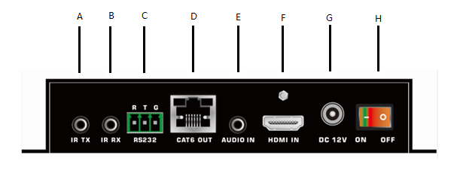
A: IR transmitter port
B: IR receiver port
C: 3-pin RS232 port
D: RJ45 output port
E: Audio input port
F: HDMI input port
G: DC 12V input port
H: OFF/ON switch

Receiver
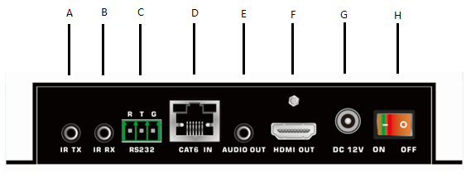
A: IR transmitter port
B: IR receiver port
C: 3-pin RS232 port
D: RJ45 input port
E: Audio output port
F: HDMI output port
G: DC 12V input port
H: OFF/ON switch

6. Operation

6.1 Connection Diagram
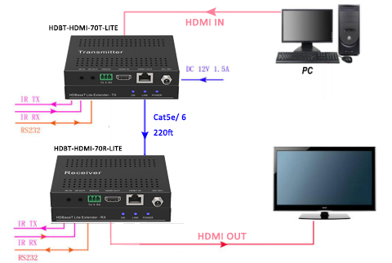

6.2 POC(Power over cable), only need to power on one end.
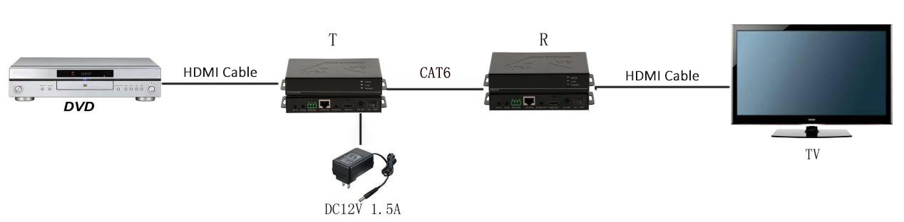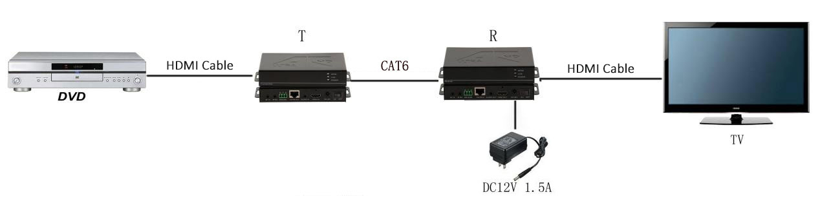

6.3 Bi-directional IR signal transmission
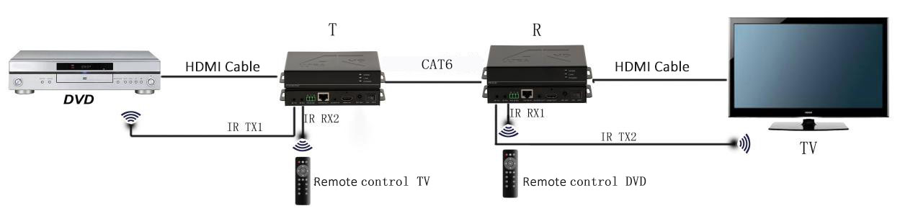

6.4 RS232signal transmission
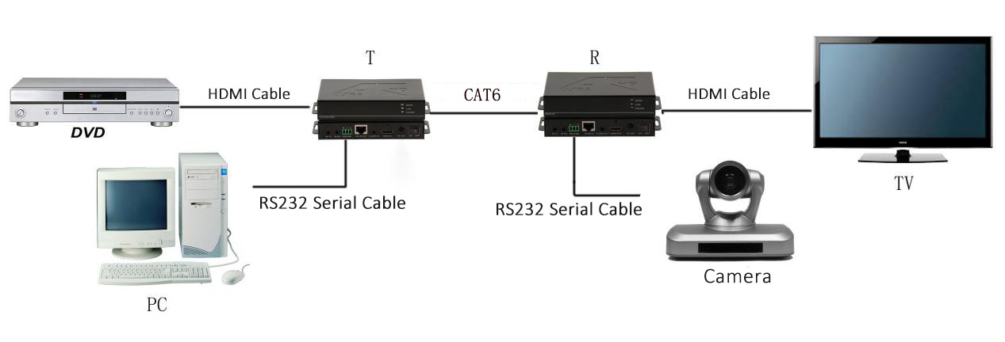
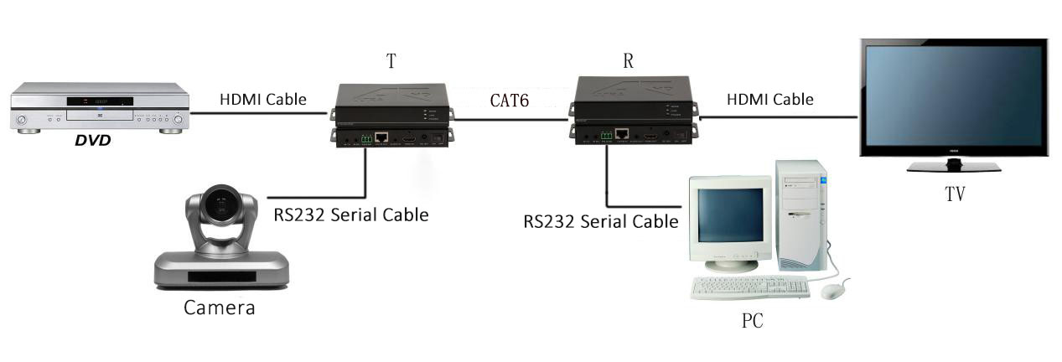

6.5 Indicators
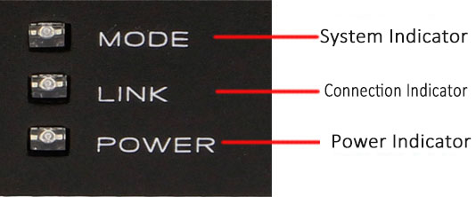
POWER: The indicator will light up when power on
LINK: It will light up when the transmitter and receiver connected successfully, flecking means
connection is not stable, off means the connection is failed.
MODE: It will flick once per second if the system runs good, on the contrary, it will be off
or light up.

6.6 EDID Management DIP Switch
The EDID management map is on the bottom panel of the transmitter, and the DIP switch is just right with the map. Specific functions, please check as below:
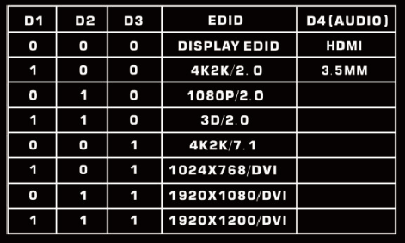
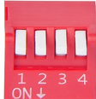
Eg: Users want to use the internal1080P2.0 EDID,
Pull the DIP switch D1,D 2, D3 to 010.
Want to use the Display EDID,
Pull the DIP switch D1,D 2,D 3 to 000.
Want to use the External audio(3.5mm),
Pull the DIP switch D4 to 1
Note: If need to use the internal 3.5mm audio, the video formats must be HDMI.

6.7 RJ-45 connector
Suggest to use twisted shield pair 24AWG cable, the bandwidth at least 400MHz, and crystal connector.
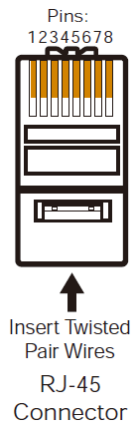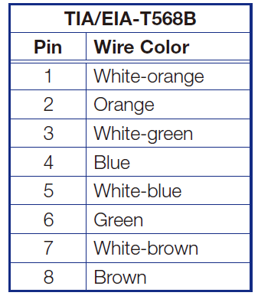

6.8 RJ-45 cable using requests
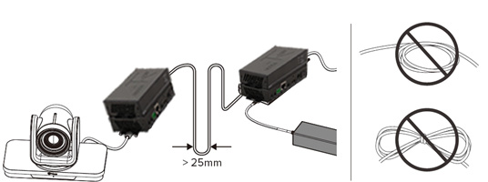
The gap between cables should above25mm, don’t circle it knot

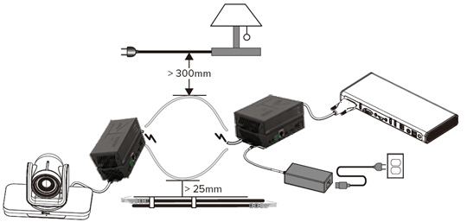
RJ-45 cable should away from high voltage cable, at least above 300mm; Also should be away from line tube at least 25mm

7. Common problem and notice

7.1 Common problem shooting

Please check below parts when the display showing no signal, audio, flicking, blue or black screen:
(1) Check the connection of the RJ-45 cable, HDMI cable
(2) Check the crystal connector and the RJ-45 cable is CAT5E/CAT6/CAT7
(3 ) Check the source input are correct
(4) Be aware of the status of the indicators and find out the problems

7.2 Notice
- All the RJ-45 cable, power cord should have the protection cover when assembling,
better cover the cable to avoid out pressure to damage the cables
(2) Please don’t hang up stuff over the cables, don’t step on the cables to avoid
short circuit and damage.
(3) Please pay attention to using the properly plugging in ways to avoid cable and port damage.
(4) Please avoid the liquid getting into the equipment to damage the product and short circuit.

8. After-Sales
8.1 Warranty Information
The Company warrants that the process and materials of the product are not defective under normal use and service for 3 (3) years following the date of purchase from the Company or its authorized distributors.
If the product does not work within the guaranteed warranty period, the company will choose and pay for the repair of the defective product or component, the delivery of the equivalent product or component to the user for replacement of the defective item, or refund the payment which users have made.
The replaced product will become the property of the Company.
The replacement product could be new or repaired.
Whichever is longer, any replacement or repaired of the product or component is for a period of ninety (90) days or the remaining period of the initial warranty. The Company shall not be responsible for any software, firmware, information, or memory data contained in, stored in, or integrated with the product repaired by the customer's return, whether or not during the warranty period.
8.2 Warranty limitations and exceptions
Except above limited warranty, if the product is damaged by over usage, incorrectly use, ignore, accident, unusual physical pressure or voltage, unauthorized modification, alteration or services rendered by someone other than the Company or its authorized agent, the company will not have to bear additional obligations. Except using the product properly in the proper application or normal usage

9. Version Information
Description of version（Document number：HDBT-HDMI-70TR-AE）
Date | Version number | Description
Dec 2016 | V1.01.01 | First version

